

OAuth Configuration in Azure for Servicenow APIs

For Client

Ayush Sharma

EQUINOR ASA | ServiceNow Administration

ServiceNow Administration OAuth Configuration [Publish Date]

1. About

To enhance the security of the ServiceNow instance in Equinor OAuth 2.0 will be included along with the basic authentication. This document explains about the configurations that needs to be made to use the APIs with basic OAuth 2.0 in ServiceNow and Azure.

2. For Clients

2.1 Get Access token

Request

Use the following details to get Access token

API Endpoint: https://login.microsoftonline.com/3aa4a235-b6e2-48d5-9195-7fcf05b459b0/oauth2/token

Method: POST

Enter body parameters as given below

grant_type: client_credentials

client_id: will be shared by ServiceNow Team

client_secret: will be shared by ServiceNow Team

resource: keep it empty

Response

The response will contain the following:

access_token: token for authentication when using any ServiceNow API

expires_in: this is the time of the access_token that will get expired. This will be in seconds.

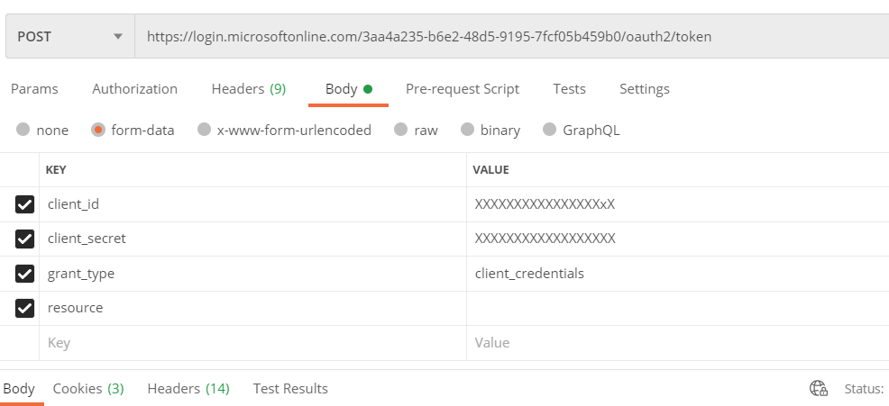

ServiceNow Administration OAuth Configuration [Publish Date]

2.2 Use access token for authentication of API

Access the ServiceNow table API or REST API by using the access_token for authentication.
To authenticate, enter the header Authorization as Bearer followed by the access_token and Ocp-Apim-Subscription-Key which will be provided by ServiceNow Team as shown below in the image below.

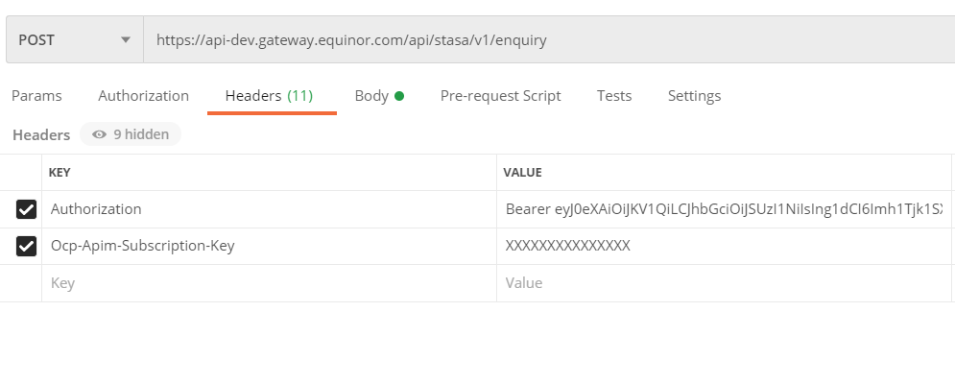After putting the Headers go to Body section and pass all the parameter which is required for the API as shown in the image below.

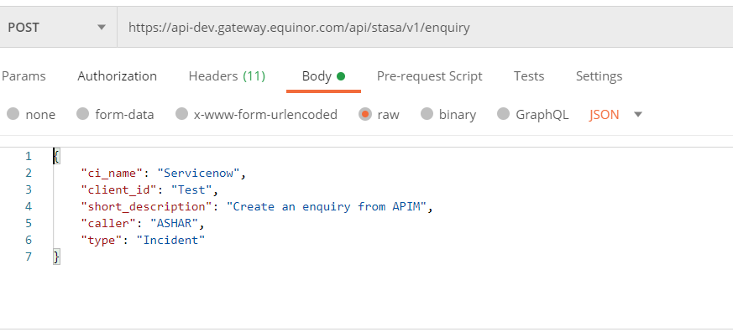

Note: In case of any query or help please drop an email to fg_sn@equinor

